**YOUTH RISK BEHAVIOUR SURVEY**

**DATA ANALYSIS AND TRENDS REPORT**

**1991-2017**

**Report created by**

**Archana Ravi**

**SiYuan**

**Kelvin**

**EXECUTIVE SUMMARY**

The U.S. Youth Risk Behavior Survey (YRBS), conducted biannually since 1991, provides national data on the health-risk behaviors of all grade students. The Youth Risk Behavior Surveillance System (YRBSS) monitors six categories of health-related behaviors that contribute to the leading causes of death and disability among youth and adults, including—

* Behaviors that contribute to unintentional injuries and violence
* Sexual behaviors related to unintended pregnancy and sexually transmitted diseases, including HIV infection
* Alcohol and other drug use
* Tobacco use
* Unhealthy dietary behaviors
* Inadequate physical activity

YRBSS also measures the prevalence of obesity and asthma and other health-related behaviors plus sexual identity and sex of sexual contacts.

YRBSS includes a national school-based survey conducted by CDC and state, territorial, tribal, and local surveys conducted by state, territorial, and local education and health agencies and tribal governments.

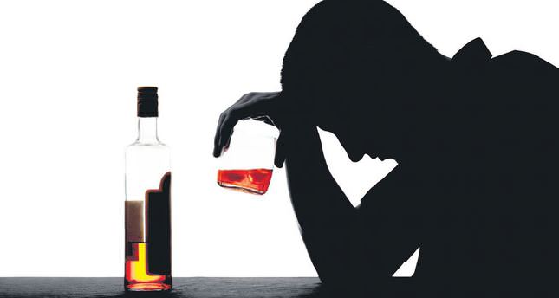

**HOW TRAUMA IS A GATEWAY TO DRUG USAGE AND ALCOHOL INTAKE?**

The things you experience in your childhood typically follow you into adolescence and adulthood. They shape how you think, behave and react to people and situations. There is a clear connection between childhood trauma and alcoholism and other addictions.

Trauma can create a variety of long-term mental health issues, including PTSD. These issues lead many to self-medicate with excessive drinking or drug misuse.

According to the Children’s Mental Health Network(CMHN), the linkage between ACE’s and trauma and substance abuse disorders (SUD’s) is compelling.In his paper, Origins of Addiction, Felitti reports that people who experience 4 or more ACE’s are 500% more likely to abuse alcohol. People who report five ACE’s or more are 7 to 10 times more likely to report illicit drug abuse. A jaw-dropping data point indicates that individuals who survive 6 or more ACE’s are 46 times more likely to be IV drug abusers than people who report no ACE’s. Trauma truly is the “gateway drug” to addictions.

**TRENDS RELATED TO SUICIDAL RATES**

This analysis helps us find the trend of Suicidal rates from 2009-2017 :

There is nearly 4.5% increase the percentage of respondents who claims to have attempted a suicide.

|  |  |  |  |
| --- | --- | --- | --- |
| **Have you attempted suicide?** | **Students who responded a ‘Yes’** | **Percentage of respondents** | **Total No of respondents** |
| **Survey year** |  |  |  |
| **2009** | 1871.0 | 11.5% | 16188.0 |
| **2017** | 2024.0 | 16.2% | 14492.0 |

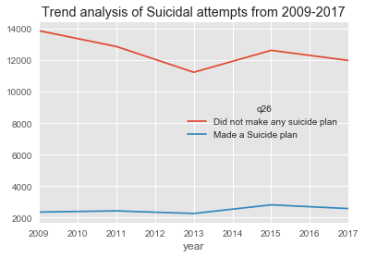

**DEPRESSION: AN OVERVIEW**



Depression is a mood disorder that causes a persistent feeling of sadness and loss of interest. Also called major depressive disorder or clinical depression, it affects how you feel, think and behave and can lead to a variety of emotional and physical problems. You may have trouble doing normal day-to-day activities, and sometimes you may feel as if life isn't worth living.

More than just a bout of the blues, depression isn't a weakness and you can't simply "snap out" of it. Depression may require long-term treatment. But don't get discouraged. Most people with depression feel better with medication, psychotherapy or both. (Mayo Clinic)

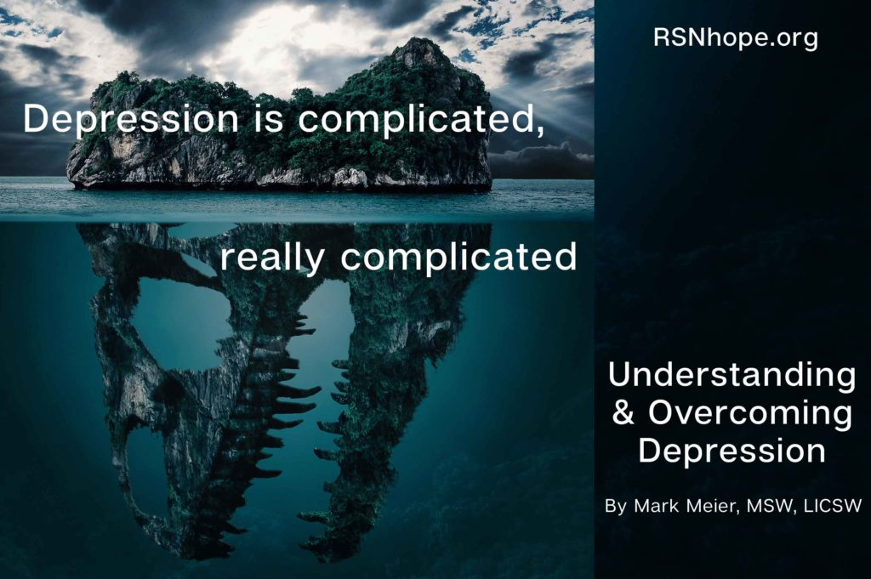

**TRENDS RELATED TO DEPRESSION**

The trends related to depression were inferred from the survey on how often they feel sad or hopeless in a day.

* The study proves that there is nearly a 4% increase in the number of students feeling sad or hopeless every single day.
* In 2009, nearly 1 in 4 students felt sad and hopeless.
* In 2017, nearly **1 in 3 students felt sad and hopeless**.

|  |  |  |
| --- | --- | --- |
| **Year of survey** | **Did not feel sad or hopeless** | **Felt Sad and Hopeless** |
| **2009** | **72.1%** | **27.8%** |
| **2017** | **68%** | **31%** |

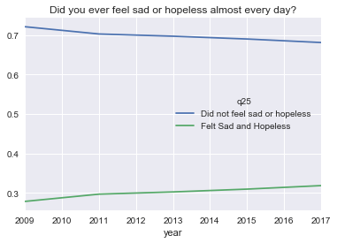

**HOW LOSS OF CONCENTRATION AS A RESULT OF DEPRESSION CORRELATES WITH OTHER CAUSATIVE FACTORS**

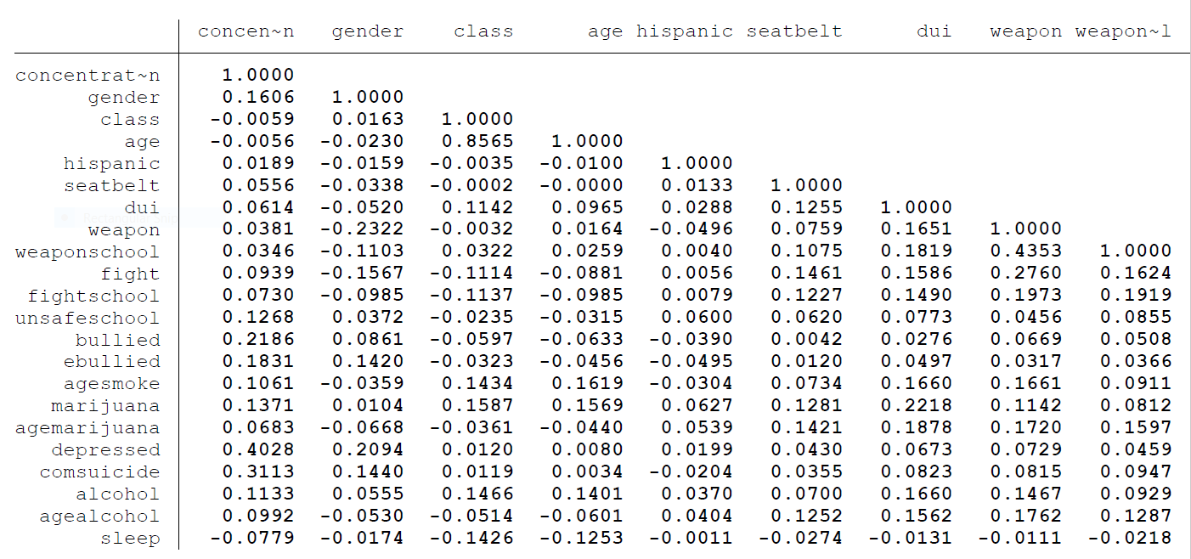

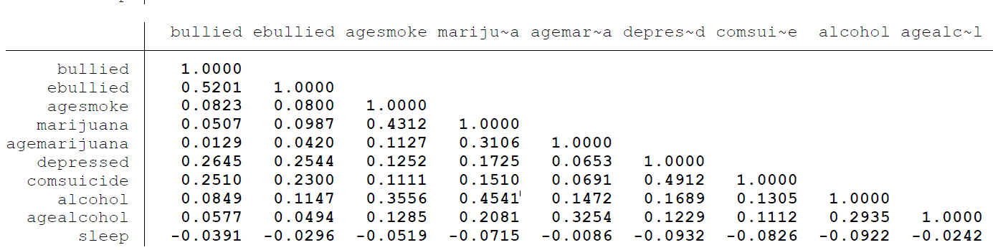

* The positive correlation between marijuana usage and “age at first smoke” (0.4312) indicates that, as the proportion of students who smoke before 13 years of age increases, the usage of marijuana also increases.
* This positive relationship is also experienced between marijuana usage and and students who drive under influence - as the students who use marijuana increases, students who drive under influence also increases.
* As students who drive under influence increases, students who rarely /never use seat belts also increase .
* As Driving Under Influence increases, the following factors also increase . i.e students who carry weapons, students who carry weapons in school, students who fight on school property and students who fight at home,students who felt unsafe at school, students bullied in school and on social media,depression, alcohol intake, age at first alcohol intake.
* The negative correlation between students who sleep more and social media bullies, indicates that students who have 8 hours or more sleep have less chances of being bullied on social media. i.e students who get less sleep night sleep hours, their chances of being bullied on social media increases.
* As students who have adequate rest/sleep increases, their chances of losing concentration decreases - Depression decreases as students have ample 8 hours or more sleep & vice versa.

**INFERENCES ON DEPRESSION**

The significant predictors of Depression amongst children are as follows, all forms of bullying, fights on school property, felt unsafe in school and students who responded to have had an adequate 8 or more hours of sleep also, students who have ever used marijuana and alcohol, students who first tried alcohol before their 13th birthday and also students who have confessed to having had suicidal thoughts were all significant predictors of depression.

**PREDICTIVE MARGINS OF DRUGS ON DEPRESSION**

1. Students who were initiated into alcoholism before the age 13 were more likely to have a higher chance of feeling depressed as compared to children who never took alcohol until after their 13th birthday.

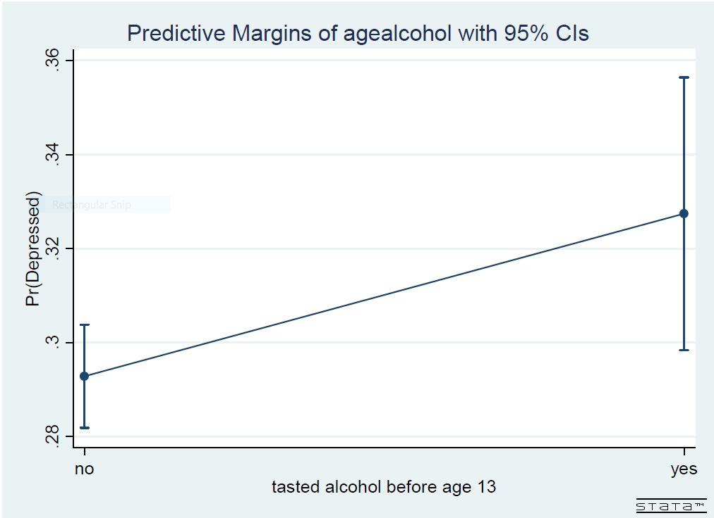

b) Students who have ever used marijuana also have a higher odds of being depressed as compared to students who have never used marijuana.

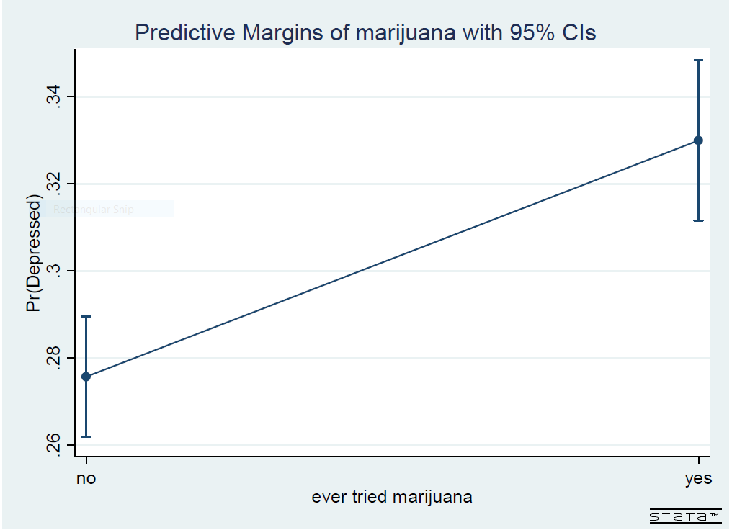

**PREDICTIVE MARGINS OF ADEQUATE SLEEP ON DEPRESSION**

Students who do not have 8 hours or more night sleep tend to be more depressed relative to students that enjoy ample 8 hour sleep.

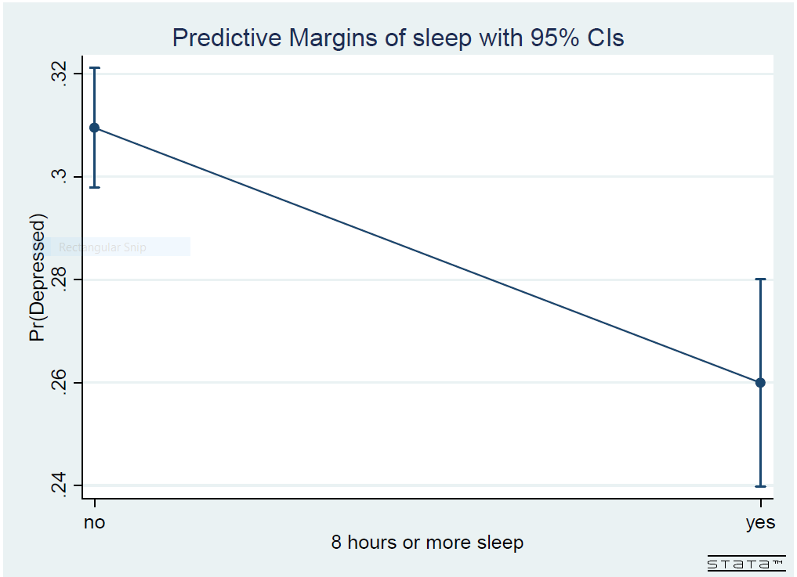

**PREDICTIVE MARGINS OF BULLYING ON DEPRESSION**

Students who confessed to have bullied in school and on social media have heightened chances of depression.

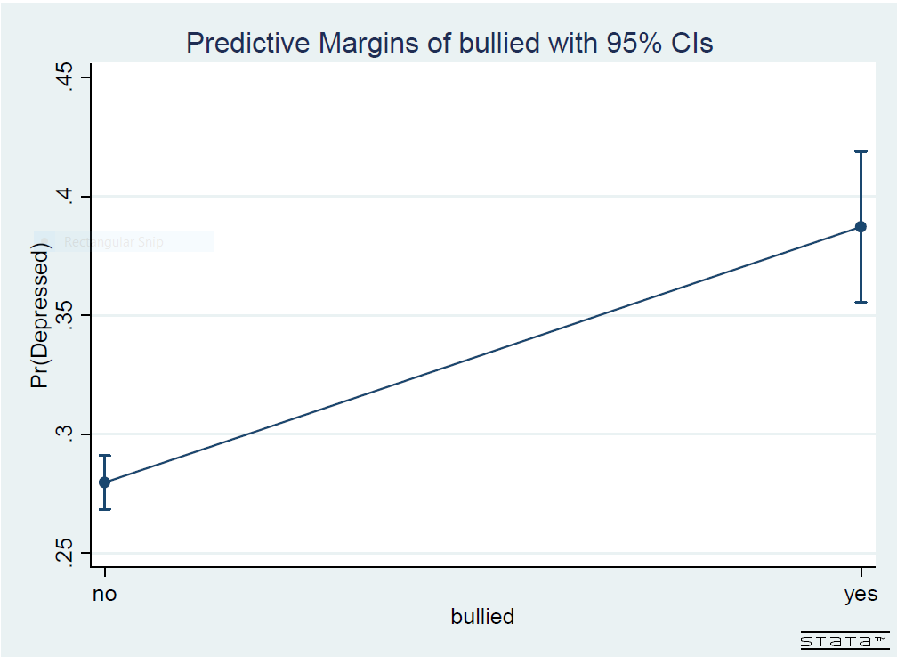

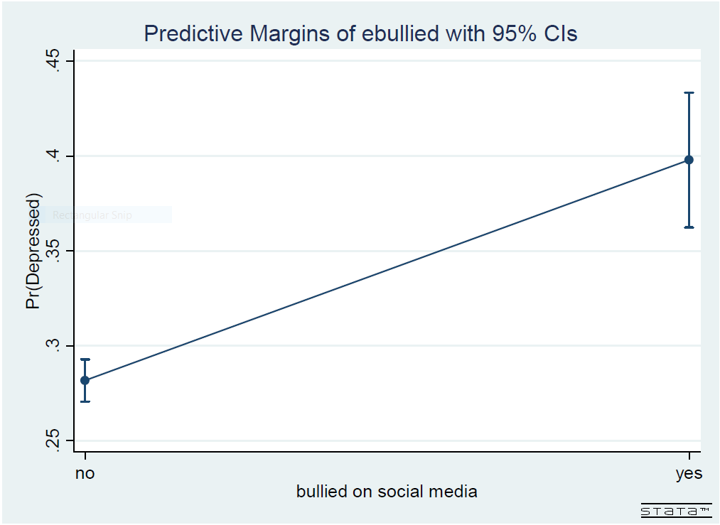

**PREDICTIVE MARGINS OF SUICIDAL THOUGHTS ON DEPRESSION**

Students who confessed to have conceived suicidal thoughts have an increased chance of getting depressed.

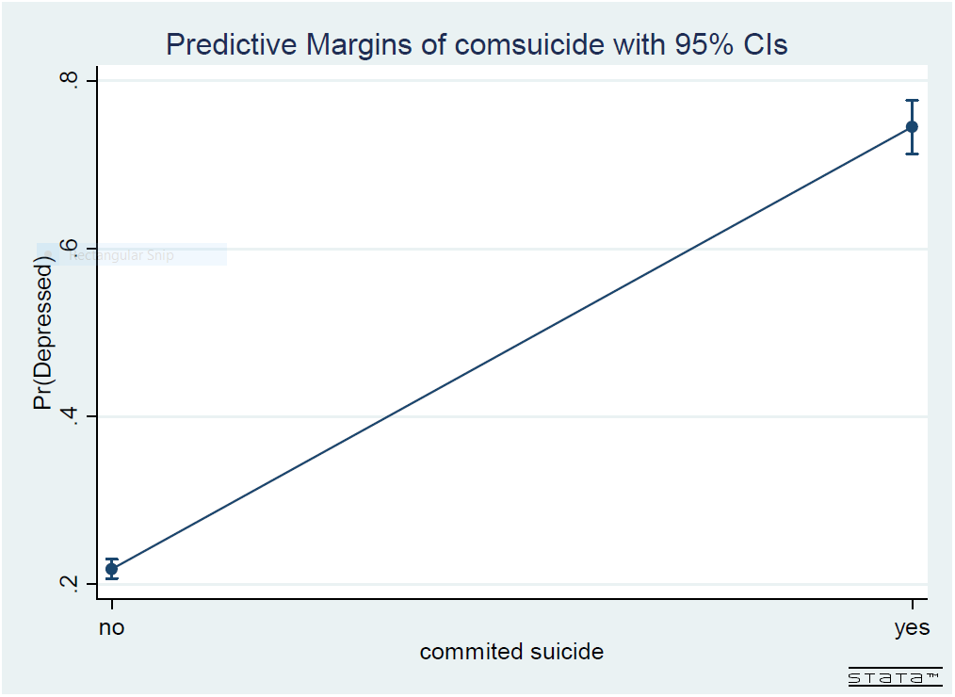

**PREDICTIVE MARGINS OF STUDENTS WHO FELT UNSAFE AT SCHOOL ON DEPRESSION**

Also students who felt unsafe at school are more likely to have a higher chance of getting depressed.

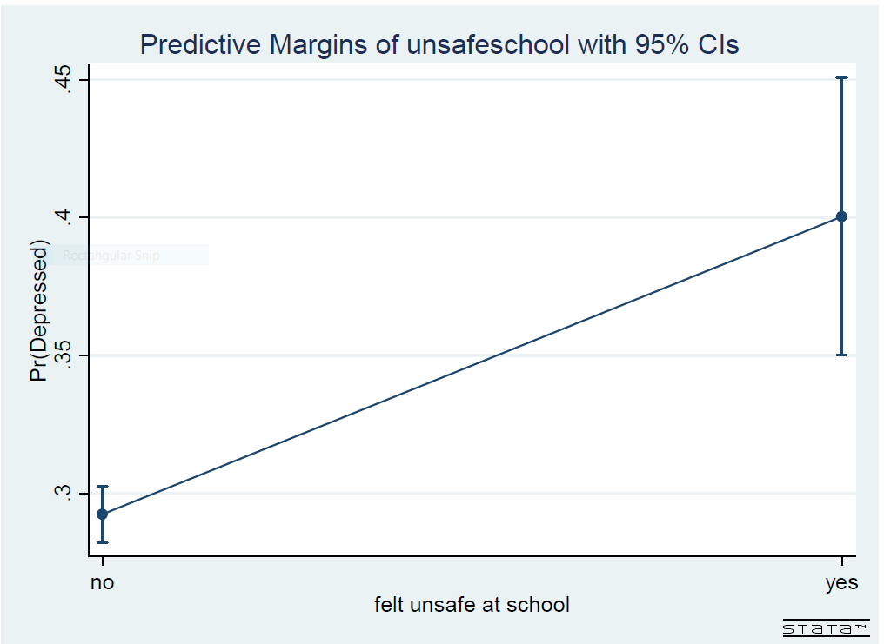

**TRENDS RELATED TO DRUG ABUSE**

* In 2009, nearly 1 in 4 students tried marijuana.
* In 2017, **almost 1 in 3 students have tried marijuana**.
* There is nearly a 5% increase in students who use Marijuana for the past 9 years.

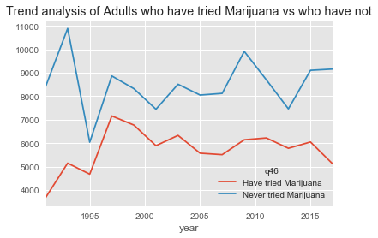

**DO MALE OR FEMALE USE MARIJUANA MORE?**

|  |  |  |  |
| --- | --- | --- | --- |
|  | **Have you tried marijuana?** | **No** | **Yes** |
| **Year of Survey** | **Sex** |  |  |
| **1991** | **Male** | **73.5%** | **26.4%** |
| **Female** | **65.4%** | **34.5%** |
| **2017** | **Male** | **63.6%** | **36.3%** |
| **Female** | **64.7%** | **35.2%** |

**BIBLIOGRAPHY**

-Data Reference :<https://www.cdc.gov/healthyyouth/data/yrbs/data.htm>

Others References:

-<https://www.gatewayfoundation.org/addiction-blog/trauma-and-addiction/>

-<https://www.cmhnetwork.org/news/trauma-is-the-gateway-drug-an-aces-informed-approach-to-substance-abuse-treatment/>

-<https://sobernation.com/the-correlation-between-trauma-and-substance-abuse/>